DS.140 Integration Design Specification



PV Adjustment Upload Interface (Oracle Apex)

Author: Akshat Farsoiya

Creation Date: Mar 19, 2024

Last Updated: Mar 19, 2024

Version: 1.0

**Approvals:**

|  |  |
| --- | --- |
| <Approver 1> |  |
| <Approver 2> | <Business Owner> |

# Document Control

## Change Record

| Date | Author | Version | Change Reference |
| --- | --- | --- | --- |
| Mar 19, 2024 | Akshat Farsoiya | 1.0 | No Previous Document |
|  |  |  |  |
|  |  |  |  |
|  |  |  |  |

2

## Reviewers

| Name | Position |
| --- | --- |
| FHL Business | Business User |
| FHL IT Group | Fortis IT Team |
|  |  |
|  |  |

Contents

1 Document Control ii

1.1 Change Record ii

1.2 Reviewers ii

2 Introduction 4

2.1.1 Scope for this Document 4

2.1.2 Intended Audience 4

3 Overview 5

3.1 Business Objectives 5

3.2 Major Features 5

3.3 Glossary 5

4 High-Level Fusion Integration flow 6

5 Technical Design Details 7

5.1 OIC Services 7

5.2 Oracle PaaS DBCS components 8

5.3 Oracle APEX – Fortis Cycle Count Upload application 9

5.3.1 PAGE LAYOUT 9

5.4 Technical flow 10

6 Data FIELD Mapping 11

6.1 File format 11

6.2 Frequency 11

6.3 Security and Access 11

6.4 Apex application Authentication scheme 11

6.5 Apex application List of Values 12

7 Assumptions / Considerations 13

8 Open and Closed Issues 14

8.1 Open Issues 14

8.2 Closed Issues 14

# Introduction

### Scope for this Document

This analysis specification document is prepared to layout the Item management Apex based application.

### Intended Audience

This document is intended for the following groups to provide the action items and consideration that are required to complete the implementation of the various Supply Chain and Finance related functionalities from Oracle Fusion.

#### Fortis Business Users

This document will be helpful for Fortis Business users to understand the technical design and process change with the new structure implemented in Oracle. The business user will validate this document after the verification of the requirement.

#### PwC Technical Team

The PwC technical team will use this document as a source technical design document to develop the technical solution to implement / deploy in Oracle Fusion.

#### Fortis IT Team

The Fortis IT Team must facilitate the PwC technical team for requisite details and other elements required from Business. The Fortis IT team is also responsible to arrange and provide required technical information wherever is required.

# Overview

Fortis Healthcare Limited (FHL) is a chain of hospitals, headquartered in India. Fortis started its health care operations from Mohali where first Fortis hospital was started. Later, the hospital chain purchased the healthcare branch of the Escorts group and increased its strength in various parts of the country. The Fortis health care also operates its hospital in Vasant Kunj, Faridabad, Gurgaon. The FMRI hospital at Gurgaon is the headquarter of Fortis healthcare with all the major facilities at the hospital.

This specification document is prepared to layout the design of the Item management Apex based application.

## Business Objectives

The following are the business objectives.

1. To have a secure, reliable, and scalable design flow to validate and interface cycle count updates to Oracle fusion.
2. To have a solution providing the monitoring capabilities.

## Major Features

The proposed solution will have the following features involved:

1. The cycle count application has been designed in Oracle APEX.
2. Multiple OIC integrations are involved for the various functionalities.

## Glossary

REST

Representational State Transfer.

OIC

Oracle Integration Cloud

# High-Level Fusion Integration flow

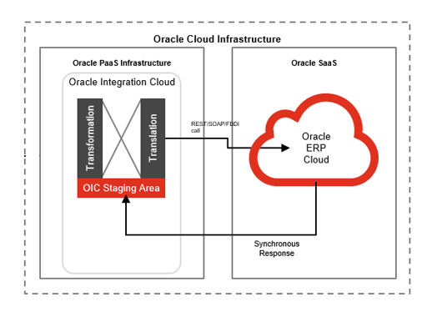

# Technical Design Details

This section describes the technical details of all the components involved in the Cycle Count Apex based application.

## OIC Services

Fortis Cycle Count Details Integration has been developed in OIC to get the details of cycle count which user has uploaded, this detail is used to validate the data which user has uploaded:

|  |  |
| --- | --- |
| **OIC Integration Name** | Fortis_Cycle_Count_Details_Integration |
| **OIC REST Endpoint URL** | [https://fortisuat-nr5lr39yailj-bo.integration.ocp.oraclecloud.com:443/ic/api/integration/v1/flows/rest/FORTIS_CYCLE_COUNT_DETAIL_INTEGR/1.0/cyclecountdetails](https://fortisuat-nr5lr39yailj-bo.integration.ocp.oraclecloud.com/ic/api/integration/v1/flows/rest/FORTIS_CYCLE_COUNT_DETAIL_INTEGR/1.0/cyclecountdetails) |
| **Method** | POST |

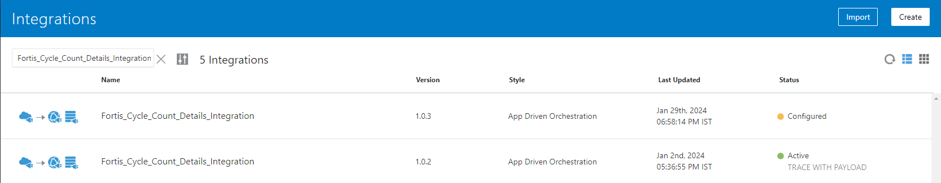

Fortis Cycle Count FBDI Integration has been developed to make files for fbdi and to triger the fbdi jobs, it also updates the errors in paas tables if fbdi returns any error:

|  |  |
| --- | --- |
| **OIC Integration Name** | [Fortis_Cycle_Count_FBDI_Integration](https://fortisuat-nr5lr39yailj-bo.integration.ocp.oraclecloud.com/ic/home/?root=integrations&oj_Router=1N4IgTg9hAuIFygGYEsA20CmYDKHrWQDsBzAZ3lCM2LAEMCJDyERSIxoB5ABwaYoC+AGhAp0WHn2YBtALojSGWmADGACwCShbgFdYLRcvUAhAJ4A1Wqh0Z4IAAQrTK1LeEhaKvncOq1AWjFMMH82DhARNSUAEyxsdmDJZEZmYAF09KA) |
| **OIC REST Endpoint URL** | [https://fortisuat-nr5lr39yailj-bo.integration.ocp.oraclecloud.com:443/ic/api/integration/v1/flows/rest/FORTIS_CYCLE_COUNT_FBDI_INTEGR/1.0/cyclecount](https://fortisuat-nr5lr39yailj-bo.integration.ocp.oraclecloud.com/ic/api/integration/v1/flows/rest/FORTIS_CYCLE_COUNT_FBDI_INTEGR/1.0/cyclecount) |
| **Method** | POST |

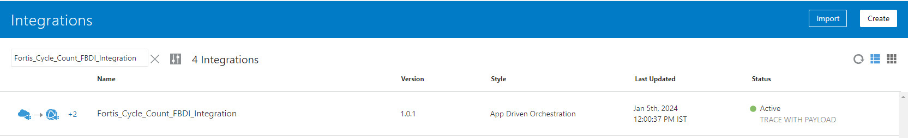

Fortis Integration Status Integration has been developed to check the status to cycle count details integration.

|  |  |
| --- | --- |
| **OIC Integration Name** | [Fortis_Cycle_Count_FBDI_Integration](https://fortisuat-nr5lr39yailj-bo.integration.ocp.oraclecloud.com/ic/home/?root=integrations&oj_Router=1N4IgTg9hAuIFygGYEsA20CmYDKHrWQDsBzAZ3lCM2LAEMCJDyERSIxoB5ABwaYoC+AGhAp0WHn2YBtALojSGWmADGACwCShbgFdYLRcvUAhAJ4A1Wqh0Z4IAAQrTK1LeEhaKvncOq1AWjFMMH82DhARNSUAEyxsdmDJZEZmYAF09KA) |
| **OIC REST Endpoint URL** | [https://fortisuat-nr5lr39yailj-bo.integration.ocp.oraclecloud.com:443/ic/api/integration/v1/flows/rest/FORTIS_CYCLE_COUNT_FBDI_INTEGR/1.0/cyclecount](https://fortisuat-nr5lr39yailj-bo.integration.ocp.oraclecloud.com/ic/api/integration/v1/flows/rest/FORTIS_CYCLE_COUNT_FBDI_INTEGR/1.0/cyclecount) |
| **Method** | POST |

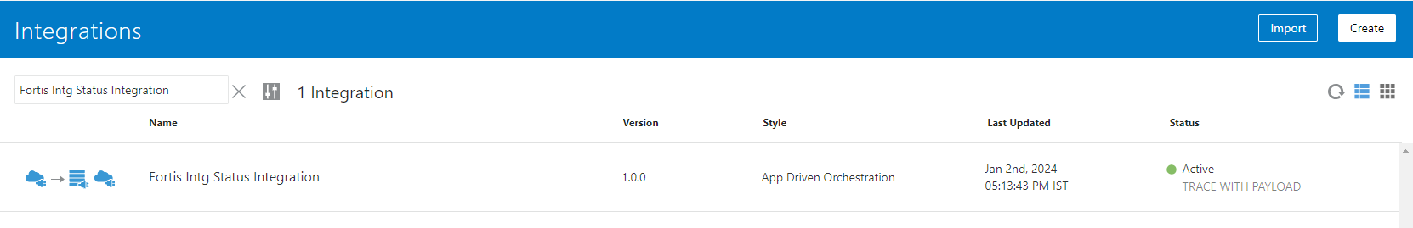

## Oracle PaaS DBCS components

This integration design uses the following components from Oracle PaaS DBCS:

|  |  |  |
| --- | --- | --- |
| **DB Component** | **Component name** | **Details** |
| **Tables** | XXFH_CYCLE_COUNT_UPD_TBL | This table is used to store the data of file which user has uploaded. |
| XXFH_CYCLE_COUNT_DETAILS_TBL | This table contains the details of cycle count which  Fortis_Cycle_Count_Details_Integration has fetched from fusion. |
| XXFH_CYCLE_COUNT_OIC_DTLS_TBL | This table is used to update the status of Fortis Cycle Count Details Integration. |

## Oracle APEX – [Fortis Cycle Count Upload](https://fusionbolton.fortishealthcare.com/portal/fh_ws/r/fortiscyclecountupload/uploadexcel?session=13765742639444) application

This application consists of the following pages mainly:

| S. No | Page Title | Description / Function | Key Features |
| --- | --- | --- | --- |
| 1 | Upload | Allows the users to upload the files. | * Users can upload and view the uploaded data. * Save button stores data from file to paas table. * Clear button clears the selected file. |
| 2 | View  Uploaded  Data | Allows the users to submit their file for FBDI | * Validate button is used to run validations on the data which user has uploaded. * After data is validated, validated records are submitted for FBDI. * Users can view status for records. * Errored records can be viewed here with error message. |

### PAGE LAYOUT

* Following is the Home page which is “Upload” to upload files.
* This same page also has a section for viewing the data which user has uploaded.

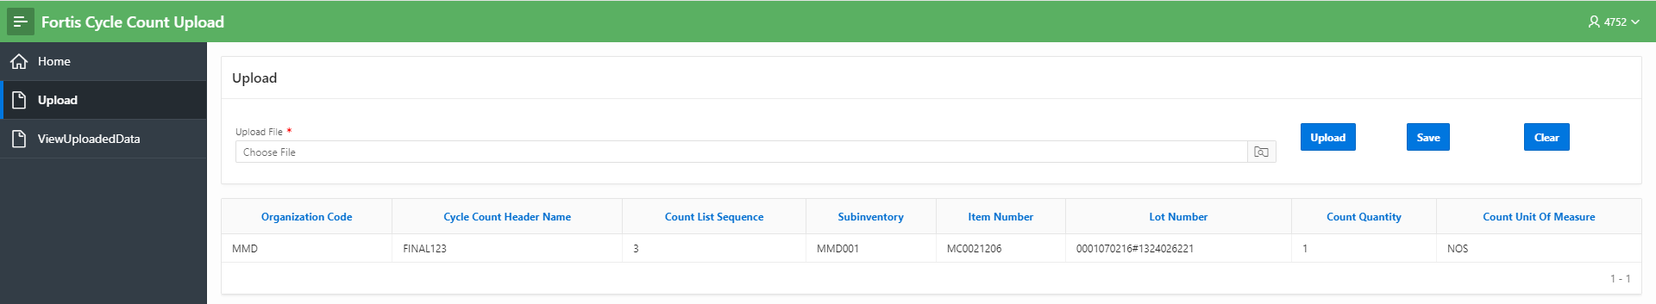

| Page Field / Button Name | Field / Button | Page Name | Page Section | Mandatory? | Field / Button Derivation Logic | Placement & Comments |
| --- | --- | --- | --- | --- | --- | --- |
| Upload | Button | Upload |  |  | This button is used to upload file to temporary collection. |  |
| Save | Button | Upload |  |  | This button is used to store data from temporary collection to paas table. |  |
| Clear | Button | Upload |  |  | It is used to clear the uploaded file. |  |
| Upload File | Field | Upload |  |  | This field is used to browse file.  File Drag and drop also works on this filed. |  |

* Following is the “View Uploaded Data”, which is used to search the uploaded files and to submit the file for FBDI.

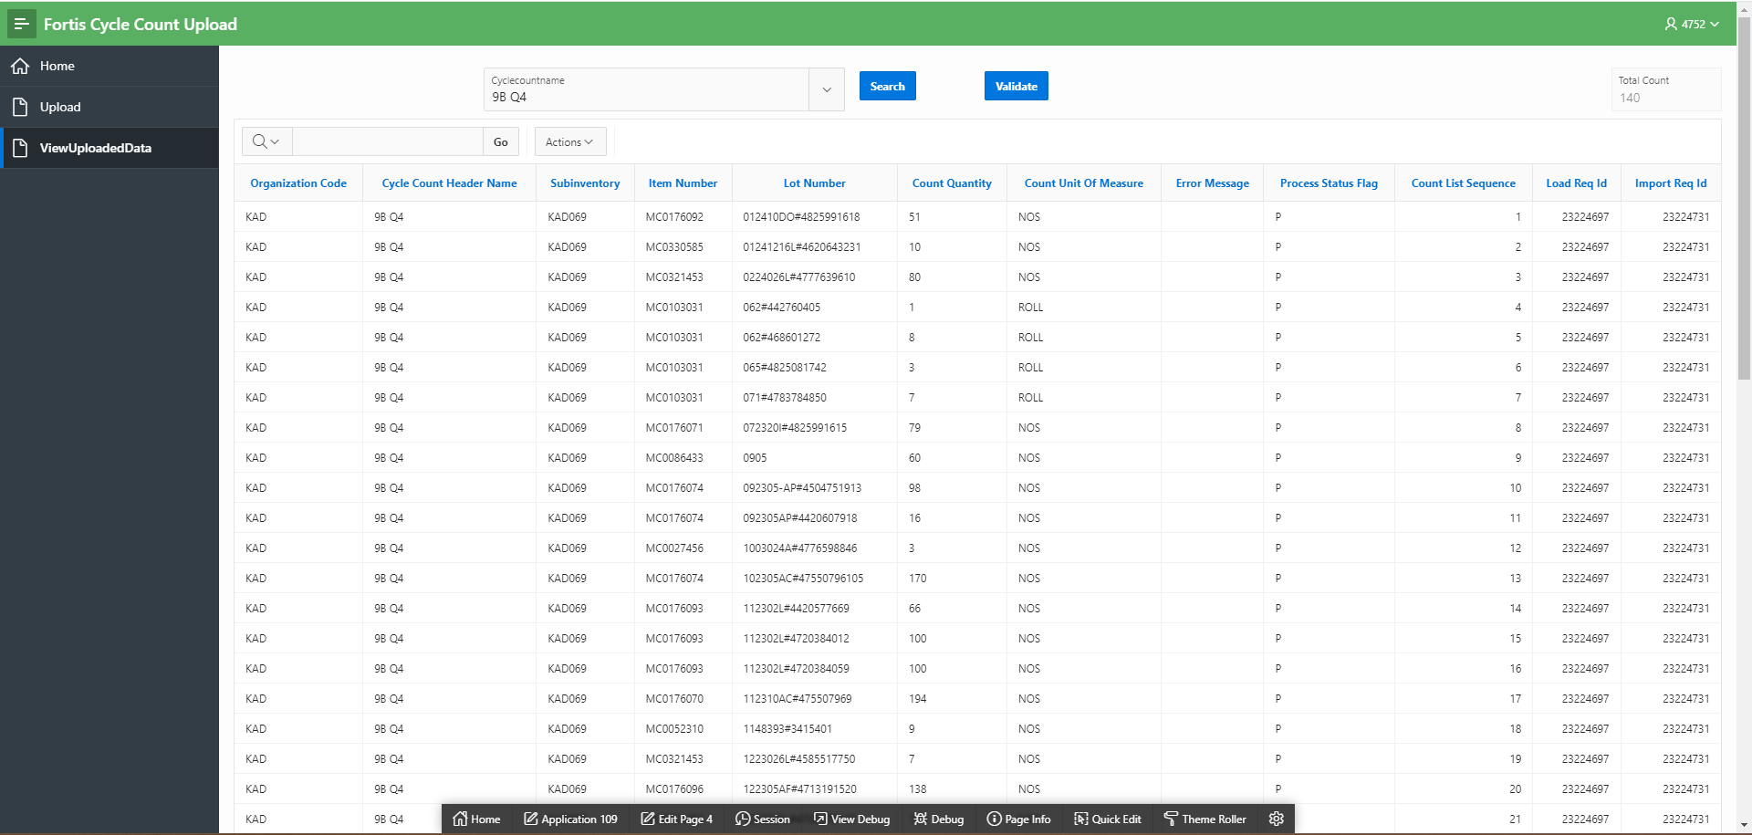

| Page Field / Button Name | Field / Button | Page Name | Page Section | Mandatory? | Field Type | Field / Button Derivation Logic | Remarks |
| --- | --- | --- | --- | --- | --- | --- | --- |
| Cycle  Count  Name | Field |  |  |  | LOV | To browse the uploaded files. |  |
| Search | Button |  |  |  | Text | Search the name selected in field and display file content. |  |
| Validate | Button |  |  |  | LOV | Run validations on the selected cycle count and submit them for FBDI. |  |

## Technical flow

Following is the complete technical flow for this integration design:

**Server details:**

|  |  |  |  |  |
| --- | --- | --- | --- | --- |
| **Server** | **Host name** | **Port** | **Service Name** | **Username** |
| Oracle PaaS DB | 140.238.225.129 | 1521 | PRODPDB1.fhpubsn.fhvcn.oraclevcn.com | XXFH & XXFH_RO |

# Data FIELD Mapping

NA

## File format

NA

## Frequency

NA

## Security and Access

Cycle Count application can be accessed via Fusion application, any of the following custom roles are required to access it, however the functionality access within bolt-on shall be different as per the role:

|  |  |  |
| --- | --- | --- |
| SI No | Role Code | Meaning |
| 1 | JOB_CYCLE_COUNT_SCM | Users in fusion with this role can access the application. |

## Apex application Authentication scheme

Item management application’s authentication is validated using the following authentication scheme defined within Oracle APEX. This authentication scheme basically invokes a procedure: XXFH_CUSTOM_AUTH.ITEM_AUTHENTICATE_USER by passing the entered username & password. This procedure validates this credential against the details present in XXFH_PER_USERS table and allow successful login to the application if the credentials & access are correct. Otherwise, user get “invalid credential” error.

XXFH_PER_USERS.ITEM_APP_ACCESS_FLAG is set to Y if the given user has any of the 5 roles assigned for Item (defined under 6.3 section). This flag is also validated within this procedure to check if the given user should be able to login to the Item management application or not.

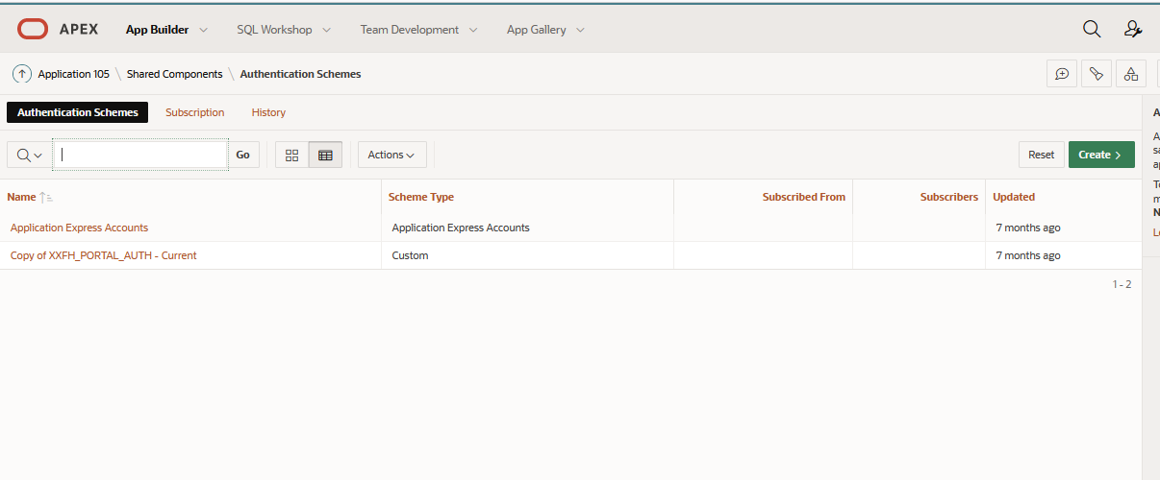

## Apex application List of Values

NA

# Assumptions / Considerations

The Proposed Solution will have the following technical considerations.

In the future, if any product bug arises in functionality then this process needs to be revisited after the bug is fixed.

# Open and Closed Issues

## Open Issues

| ID | Issue | Resolution | Responsibility | Target Date | Impact Date |
| --- | --- | --- | --- | --- | --- |
|  |  |  |  |  |  |
|  |  |  |  |  |  |
|  |  |  |  |  |  |
|  |  |  |  |  |  |

## Closed Issues

| ID | Issue | Resolution | Responsibility | Target Date | Impact Date |
| --- | --- | --- | --- | --- | --- |
|  |  |  |  |  |  |
|  |  |  |  |  |  |
|  |  |  |  |  |  |
|  |  |  |  |  |  |